Policy and Procedure for requesting a Grant from the Ohio AMVETS Charities
• All applications for a grant request must be received to the Department by January
1st prior to Mid-Winter Conference, May 1st prior to June Convention and September 1st prior to Fall Conference to be considered. Emergency applications may be considered.
•If a Post has already had an approved grant within their eligibility year, and the Post has demonstrated a verified emergency need that could lead to a Post's closure, then that same Post can apply for an additional grant within the same year as their original grant. Posts are eligible for 1 regular grant and emergency grants as needed during the same eligibility year. Eligibility for grants is determined on a yearly basis. For example, a Post that has received a grant in October of one year, regains their eligibility in October of the following year. During an active grant period, that same Post would only be eligible for an emergency grant, if it's determined to be a Health, Life, Safety, or Operational need that could hinder a Post being open for its members. The cap on all grants is $40000.00. The annual Post total grant award cannot exceed $40000.00 during the eligibility period. If a Post has one grant for $20000.00 additional emergency grants of $20,000.00 can be considered, there by not exceeding the cap of $40,000.

Emergency grants will be considered on the basis of Health, Life, Safety, or Operational need of a Post. Emergency grants are not automatic. All factors will be considered during the application for an Emergency grant.
- No subsidiaries can apply, only Posts.
- Have a representative from the Post attend the Ohio AMVETS Charities meeting to explain the request.
Grant Requests must include:
- First page of 990.
- Current bank statements for all accounts.
- Two quotes for the requested grant (e.g.: beer cooler, roof repair, etc.).
- Proof of purchase or completion of project must be sent to the Ohio AMVETS Charities (receipts and pictures).
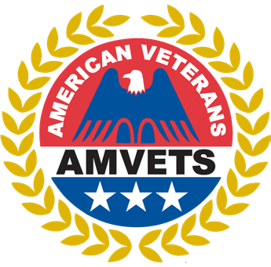
Ohio AMVETS Charities (OAC)
960 Checkrein Avenue Columbus, OH 43229

Grant Request Form
Requesting Organization Information:
Name:
Address:
City: State: Zip:
Contact: EIN:
Phone: Email:
Project Title:
Grant Date: | Amount Requested:
Grant Detail:
Statement of Need:
Please specify in detail why you are applying for this grant and what this grant will be used for. If it is going to be used for a program, please include the time period this grant will cover. For example, “Post 25 will be using funds provided by this grant to feed homeless veterans once a week at the Post for the next 12 months.”
Documentation of Financial Need
Documentation of Financial Need is a budgetary analysis that grant requestors write to justify financial need for a grant through Ohio AMVETS Charities.
Current IRS Form 990 (front page):

Current bank balance and bank statements (as of the date of the request):
Total annual income (from most recent fiscal year):
Total annual expenses (from most recent fiscal year):

Monthly Budget
 | DATE | ITEM | INCOME | EXPENSE |  | BALANCE
 | TOTALS
Printed Name of Grant Requestor, Organization Name and Title |  |  |  |  |  |  | Phone number
Signature of Grant Requestor |  |  |  |  | Date
For Office Use Only
Grant Action:
Approved
Rejected
Returned
Other
Comments:

118

